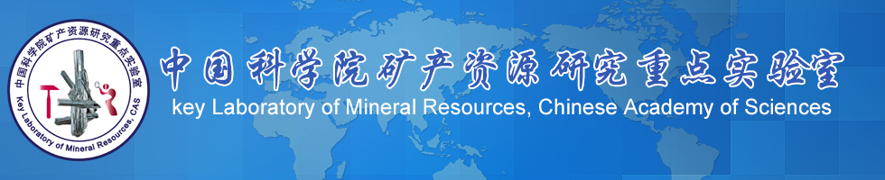

Project No.
KLMR2017-

Key Laboratory of Mineral Resources, Chinese Academy of Sciences

Application for Open Research Fund

Project title:
Applicant:
Affiliation:
E-mail:
Date of Application:

Name of the Applicant |  |  | Sex |  |  |  | Birthday
Degree |  |  | Professional |  |  |  | Telephone
Email
Title of the project
Participants for the project
Period of the project | From M/Y  To M/Y |  |  | Approved data
Amount applied | USD |  |  | Aproved amount
Note：the area with bold frame will be written by KLMR
Application content：（Please write the application refer to the following outline）

1. Background for the proposed project (less than 500words)
2. Key scientific problems will be solved ( less than 100 words)
3. The aims and goals of the proposed project (less than 100 words)
4. Implementation plans for proposed project (less than 500 words)
5. Schedule for the proposed project (less than 200 words)
6. The originality of the proposed project (less than 200 words)
7. Resume for the applicants (including published paper or licensed patent)
8. The budget for project (not including the international and domestic travelling expenses)

Recommendation (graduate student and post-doctor are required to submitted)：

Comments from the Academic Committee of KLMR：

Applicant (Signature) |  |  |  |  | Date
Director (Signature) |  |  |  |  | Date

Note：
The acheivement of the project belongs to the Key Laboratory of Mineral Resources, Institute of Geology and Geophysics, Chinese Academy of Sciences, which should be marked as the first or second position as following when publish papers or apply for patents:
Key Laboratory of Mineral Resources, Institute of Geology and Geophysics, Chinese Academy of Sciences, Beijing 100029, China

